
 | PP 1: Display Stock/Requirements List
Exercise Use the SAP Easy Access Menu to display the Stock/Requirements List. Time 5 min
Task Review the material status of your Deluxe Touring bike (finished good) in the Dallas plant using the Stock/Requirements list.
Name (Position) Lars Iseler (Production Order Worker)
The Stock/Requirements list contains up-to-date information on the current status of inventory on hand, requirements, and receipts. It is a dynamic list that allows you to view changes made to material status. |  | Stock/Requirements List
To review the material status, follow the SAP Easy Access menu path:  Logistics ► Production ► Production Planning ► Demand Management ► Environment ► Stock/Requirements List  The following screen will appear. |  | Menu path
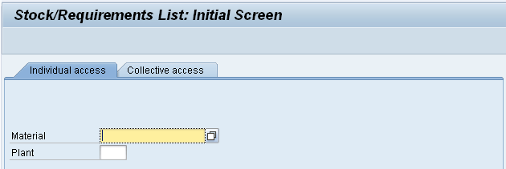
First of all, you need to find the material number(s) for your Deluxe Touring bikes. In order to do so, click in the Material field and press F4 (or click on the search icon next to the field). This will produce the following search screen. |  | F4
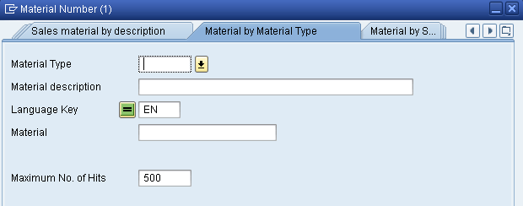
Make sure that you are on the Material by Material Type tab. If not, you can use the icon (in the top-right corner) to display a list of all search tabs available.
In the Material Type field, select Finished Product (FERT). In order to display your Deluxe Touring bikes only, you need to define two more search criteria. First, in the Material Description field type Deluxe*. Second, in the Material field (which is the field for the unique material number) type *###. Remember to replace ### with your three-digit number, e.g. *014 if your number is 014. |  | Finished Product  Deluxe*  *###
Before pressing Enter or clicking on to start the search compare your entries with the screen below.
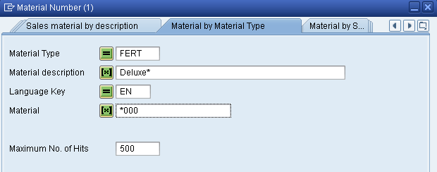
The result of this search should give you a list of:
a) all finished goods,
b) which name (short description) starts with Deluxe,
c) which material number end with your number (###).
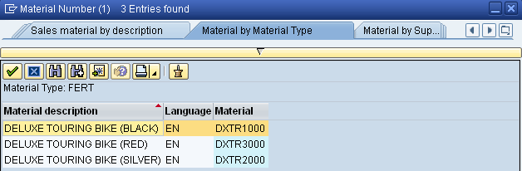
You should get a list of three different Deluxe Touring bikes – black, red and silver (please note that the material numbers in your screen will be different). Double-click on your red Touring bike which will copy its unique material number (DXTR3###) into the Material field |  | DXTR3###
In addition to the material number, in the Plant field select GBI’s manufacturing facility in Dallas (DL00). Then, press Enter or click on . You should be displayed a screen similar to the one shown below. |  | DL00
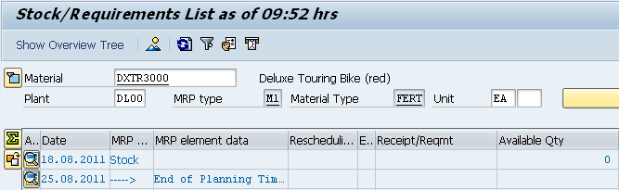
As you can see, GBI has currently no black Deluxe Touring bikes on stock. Repeat the same procedure for the other two deluxe bikes (red and silver).
Click on to return to the SAP Easy Access Menu.

 | PP 2: Display Bill of Material
Exercise Use the SAP Easy Access Menu to display a bill of material. Time 5 min
Task Review the components of your black Deluxe Touring bike and the components of the Touring Aluminum Wheel Assembly within the finished bike bill of material.
Name (Position) Jun Lee (Production Supervisor)
A bill of material (BOM) is a list of the components that are needed to create a given product. The list contains the description, the quantity, and unit of measure. The BOM can contain items of different item categories such as stock items, non-stock items, document items, and text items. |  | Bill of Material (BOM)
To review a bill of material, follow the menu path:  Logistics ► Production ► Master Data ► Bills of Material ► Bill of Material ► Material BOM ► Display  This will produce the following screen. |  | Menu path
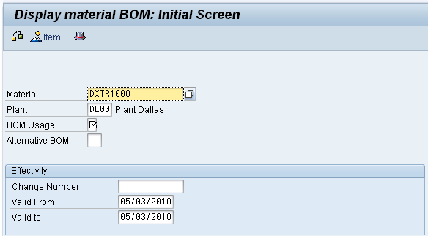
The system should have already defaulted in the material number (DXTR1###) and the plant (DL00) from the previous exercise. It also assumes that you would like to display the BOM valid today (note Valid From and Valid to dates). In addition, the system requests the usage of this BOM. Click in the BOM Usage field and use F4 to display possible usage types. Select usage type 1 for plant DL00. Then, press Enter to display the BOM of your black Deluxe Touring bike. |  | DXTR1###  DL00  F4  1
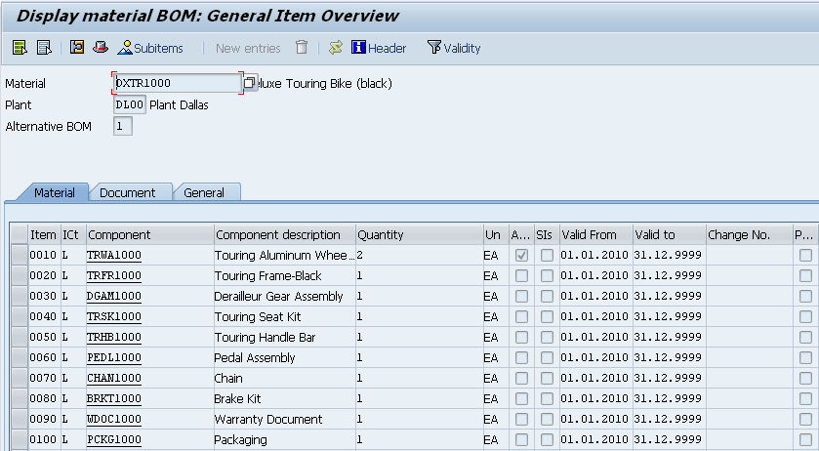
The assembly indicator (column Asm; see circled area above) marks the item with components that have their own BOM. In this case, it is the Touring Aluminum Wheel Assembly.
Double-click on this checkbox (indicator for Wheel Assembly TRWA1###). This will produce the following screen. |  | TRWA1###
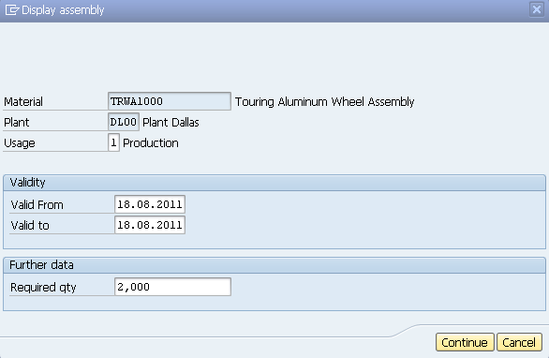
In the Display assembly screen, click on . This will display the materials that make up the assembly of TRWA1###.
Repeat the procedure for your red and the silver Deluxe Touring bike to identify the differences in their bills of materials. You may open another (parallel) session to compare the BOMs in separate screens (use the icon in the system tool bar).
Click on twice to return to the SAP Easy Access Menu.

 | PP 3: Display Multi-Level Bill of Materials
Exercise Use the SAP Easy Access Menu to display a multi-level BOM. Time 5 min
Task Review the BOM for your black Deluxe Touring bike from a multi-level hierarchy level.
Name (Position) Jun Lee (Production Supervisor)
To display a multi-level BOM, follow the menu path:  Logistics ► Production ► Master Data ► Bills of Material ► Reporting ► BOM Explosion ► Material BOM ► Multilevel BOM |  | Menu path
In the following screen, enter (or find) Material DXTR1### (replace ### with your number), Plant DL00, and BOM Application PP01 (Production-General). Then, click on to display the BOM structure for your bike valid today. If the system requests a quantity, enter 1. |  | DXTR1##  DL00  PP01  1
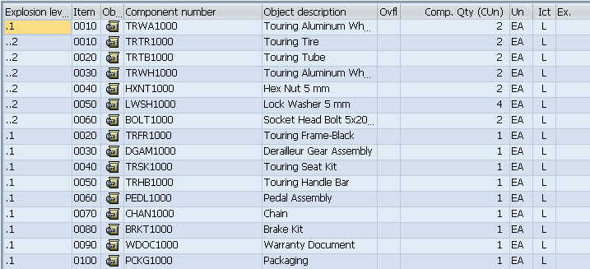
Click on to go back to the initial screen. There, you click on (View). On the following screen, in the Display field group select Variable list and click on . |  | Variable list
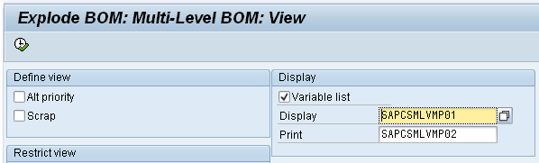
After reviewing the components of your Finished Bike, find and select the following item in the system menu:
Goto ► Graphic
This should produce the following BOM hierarchy graphic.
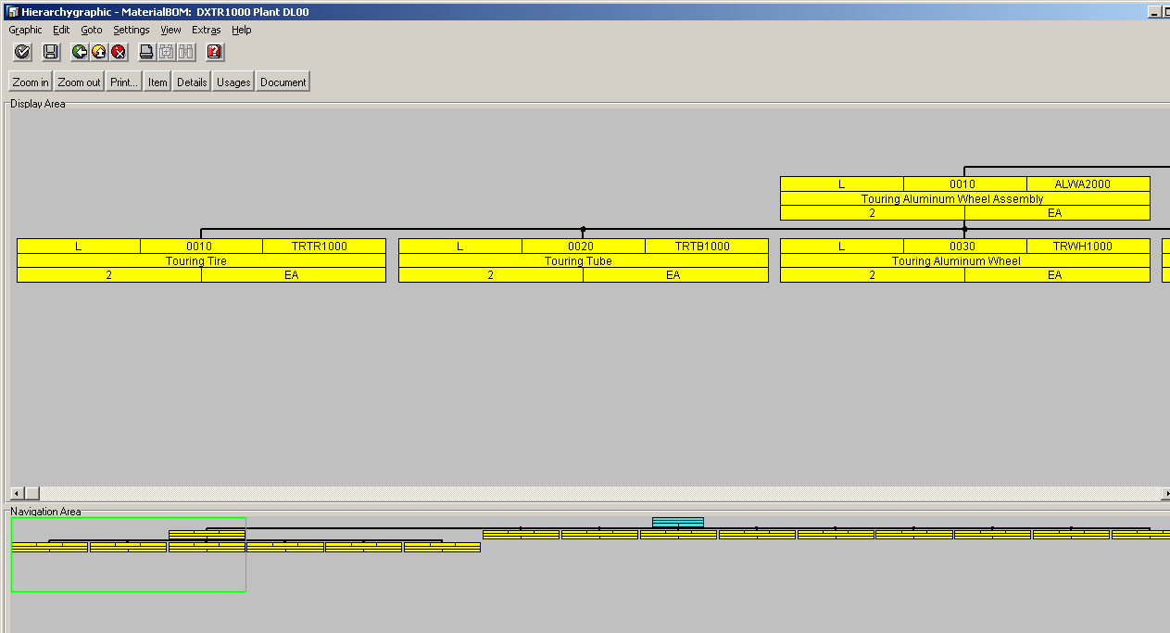
You can use the Zoom in and Zoom out buttons to resize the graphic.
Click on to exit the graphic screen. Then, click on again to return to the SAP Easy Access Menu.

 | PP 4: Display Routing
Exercise Use the SAP Easy Access Menu to display a routing. Time 10 min
Task Review the routing for your black Deluxe Touring bike.
Name (Position) Jun Lee (Production Supervisor)
A routing is a series of sequential operations carried out to produce an end product. Routings contain information on where work is to be performed, steps that need to be completed, and time lines assigned for each operation. |  | Routing
To review a routing, follow the menu path:  Logistics ► Production ► Master Data ► Routings ► Routings ► Standard Routings ► Display |  | Menu path
Enter Material DXTR1### and Plant DL00. Then, click on to display the following list of operations. |  | DXTR1###  DL00
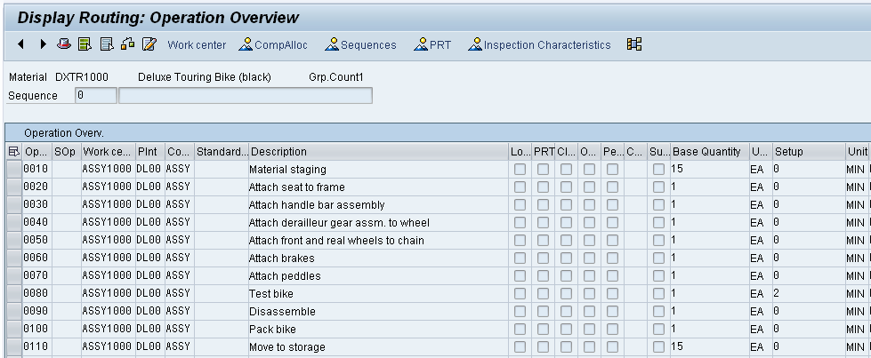
Select to display the list of components. None of them is assigned to any specific operation (note that column Oper./Act. is empty).
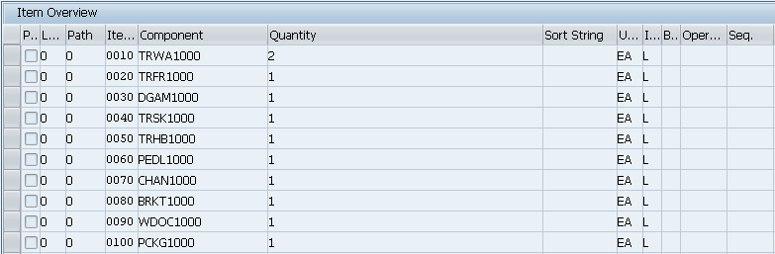
Select to go back to the operation overview. Then, click on .
This will display the following operation graphic.
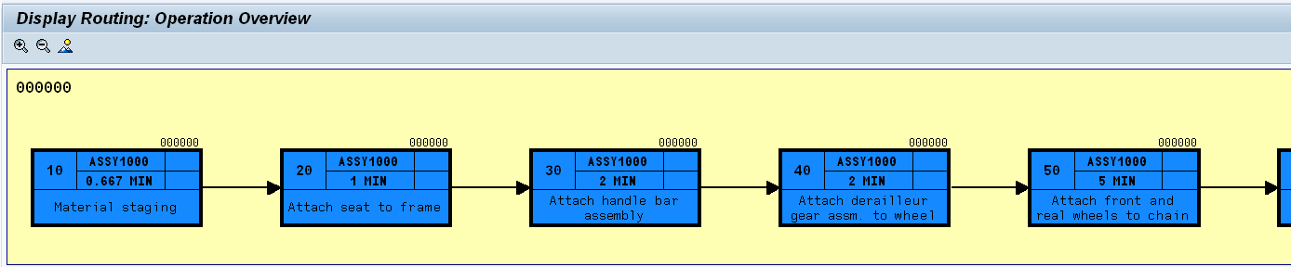
Click on to go back to the operation overview. Then, find the following system menu item:
Extras ► Scheduling ► Schedule
This should produce the following screen.
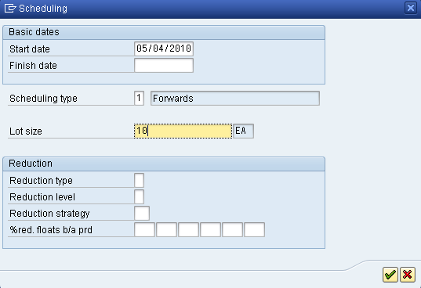
Enter Scheduling type 1 and Lot size 10. Click on . In the following screen, find and enter overview variant 000000000001 (Operation segments). Confirm your entry with . |  | 1  10  000000000001
In order to view the schedule in a Gantt chart, click on . Find the following system menu item:
Time unit ► Minute
Also, display the legend by clicking on .
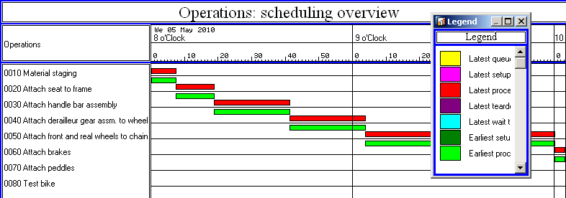
Click on and on Yes to quit the Gantt chart. Then, click on to return to the SAP Easy Access Menu. |  | Yes

 | PP 5: Display Routing/BOM in Engineering Workbench
Exercise Use the Engineering Workbench to display a routing and a BOM. Time 10 min
Task Review the BOM and routing simultaneously.
Name (Position) Jun Lee (Production Supervisor)
The Engineering Workbench (EWB) provides an environment where you have the ability to create, change, and delete BOM and routings. More importantly, it gives us the ability to create work lists and work on specific parts of a BOM or routing without locking the entire object. |  | Engineering Workbench (EWB)
To review BOMs and routings simultaneously, follow the menu path:  Logistics ► Production ► Master Data ► Engineering Workbench |  | Menu path
In the following window, find and select Current Working Area FK (Test Work Area) using the F4 help and click on . |  | FK
In the EWB: Selection Criteria for BOM Headers screen, enter (or find) Material DXTR1### (replace ### with your number) and Plant DL00. Then, click on . If the system requests a Change number in a separate screen, leave it blank and click on . |  | DXTR1###  DL00
In the EWB: BOM Headers Overview screen, if the icon is not grayed out, click on it to activate the browser. If the system requests an Application, enter PP01 and click on . |  | PP01
In order to see the icons and , use the mouse to widen the browser window (as shown below).
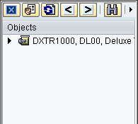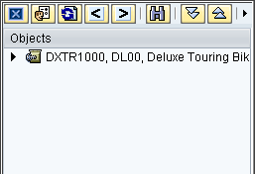
Click on (left) to select the line DXTR1###, DL00, Deluxe Touring Bike (black). Then, click on to expand the tree completely. This might take a few seconds and will result in the following screen.
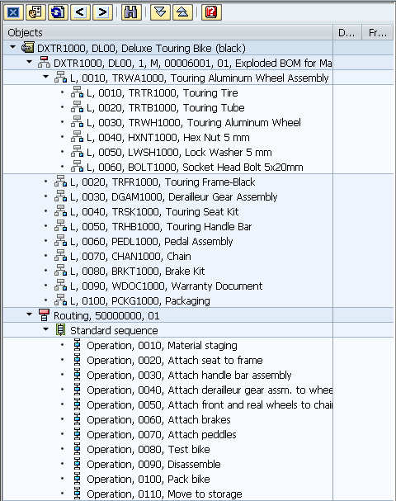
The subtree marked with comprises the entire BOM for your Deluxe Touring Bike, the subtree marked with lists all routing operations.
Double-click on operation 0020 (Attach seat to frame) to call up specific information. Here, you could change the routing details for this operation if necessary. |  | 0020
Click on and on Yes to return to the SAP Easy Access Menu. |  | Yes

 | PP 6: Display Work Center
Exercise Use the SAP Easy Access Menu to display a work center. Time 15 min
Task Review a work center in GBI’s plant in Dallas.
Name (Position) Jun Lee (Production Supervisor)
A work center is a location where operations are carried out for an order. Capacities (setup, machine, and labor) are assigned to work centers so that they can be allocated and consumed within an order in a controlled and predictable manner. The work center capacity is created in and assigned to a single work center. |  | Work center
To review a work center and the capacity assigned to it, follow the menu path:  Logistics ► Production ► Master Data ► Work Centers ► Work Center ► Display |  | Menu path
Enter Plant DL00. In the Work center field, use the F4 help to display all three work centers in Dallas. In the search results, double-click on the DL Assembly work center to select it which should copy its number (ASSY1000). Click on . |  | DL00  F4  ASSY1000
On the Basic Data tab, find out who is the person responsible.
On the Default Values tab, click in the Control key field (ASSY) and select F4. On the following screen, single-click on the ASSY. Then, select , which will indicate what is required when ASSY is used. |  | ASSY  F4
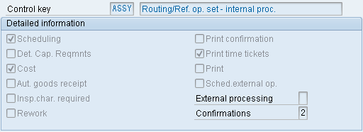
Select . Click on the Scheduling tab.
On the Scheduling tab, click in the Processing formula field and select (Display formula). After acknowledging the formula, press to continue.
After selecting (Test formula), enter Operation Quantity 100 EA, Base Quantity 1, No. of Splits 2, Setup 7 MIN, and Labor 7 MIN. Then, select (Calculate). The following screen will appear. |  | 100 EA  1  2  7 MIN  7 MIN
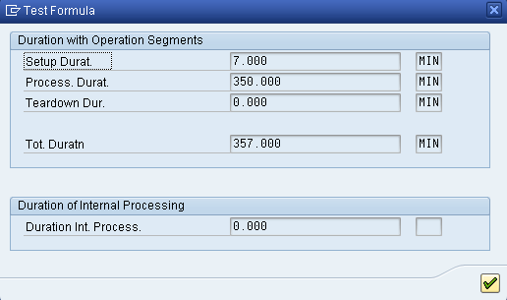
Click on to continue. Did the Processing formula work correctly?
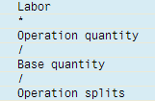 (((7 * 100) / 1) / 2) = 350
Select to go back.
On the Costing tab, what Controlling Area and Cost Center are defined?

Click on to return to the SAP Easy Access Menu.

